Book Report  
Smart Water

Management System

short line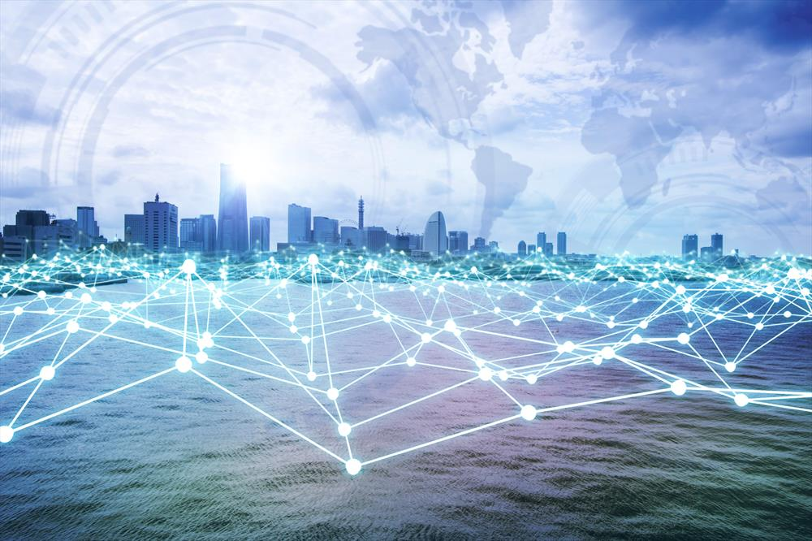

footer

Acknowledgment

*“It is not possible to prepare a project report without the assistance & encouragement of other people.*

*This one is certainly no exception.”*

On the very outset of this report, I would like to extend my sincere & heartfelt obligation forward all the personages who have helped us in this endeavor. Without their active guidance, help, cooperation, and encouragement, we would not have made headway in the project.

We are ineffably indebted to **DC’s Internship Program** for giving this worthy opportunity this internship and encourage us to accomplish this assignment

We are extremely thankful and pay gratitude to our **DC’s faculty Mr. Dileep Sir and Mr.Anupam Sir** for valuable guidance and support on the completion of this project in its present form.

We extend our gratitude to **GLA University** for giving this opportunity. Especially our honorable director sir MR. Neeraj Gupta for conscientious guidance and encouragement.

We also acknowledge with a deep sense of reverence, our gratitude towards our team members, without thor support and teamwork we may not accomplish this assignment on time.

At last but not least gratitude goes to all our parents who always supported us morally.

**Thanking You**

**GROUP - 4**

**B-Tech (CSE)**

**Sec - K (2 year)**

# Content

# 

1. Sensors 3
2. Networking 6
3. Structure development 9
4. Budget analysing 13
5. Cloud System 16
6. Benefits and silence feature of this project 17

# 

# 

SENSORS Chapter 1

*“The Internet of Things is one of the most important and promising technological topics today. Some market researchers estimate that there are more than 20 billion connected devices and counting. Around us, there are smartphones, wearables, and other devices, all of which use sensors.”*

In this report, we are using a variety of sensors and other devices. Before using any sensor we give to spend a lot of time in research and other things to the choice the best sensor on the basis of the following feature :

* It should be sensitive to the phenomenon that it measures
* It should not be sensitive to other physical phenomena
* It should not modify the measured phenomenon during the measurement process

Here is the sensor and other devices which we used in our project:

|  |  |
| --- | --- |
| 1. Lora MQTT Gateway esp32 2. 1000L Tank 3. Water Filter 4. Router 5. Carbon Nanotube 6. AC-DC Converter 7. Superhet Receiver 8. ESP8266 | 1. Tx Rx module 2. Ph sensor 3. Turbidity sensor 4. Optical level sensor 5. Relay 6. Flowmeter 7. Overflow sensor 8. Buzzer |

Let’s discuss every sensor briefly what are they used for,

Lora MQTT Gateway(ESP32): transmit data from devices to cloud.

Carbon Nanotube: this is a tube made of carbon fiber sheet which even cleans seawater and makes it available to drink.

Superhet Receiver: this is a receiver with its full name superheterodyne receiver.it ranges up to 150 m and the data transfer rate is so fast nearly(0.125sec).

Router: The main purpose of a **router** is to connect multiple networks and forward packets destined either for its own networks or other networks.

ESP8266(nodemcu): it is the best mcu device because of its wifi capabilities(802.11 b/g/n/e/i) better than arduino uno.

AC-DC Converter: it converts the ac current to dc current for our sensor as we know all our senors work on dc.

Tx Rx module: this is a set of transmitters and receivers. Transmitting data from one end and receiving it on another end.

Water Filter: it cleans the water contaminants and makes it able to reuse.

Ph sensor: A pH sensor is one of the most essential tools that's typically used for water measurements. This type of sensor is able to measure the amount of alkalinity and acidity in water and other solutions.

Turbidity sensor: Turbidity is an important indicator of the amount of suspended sediment in the water, which can have many negative effects on aquatic life. The suspended sediments that cause turbidity can block light to aquatic plants, smother aquatic organisms, and carry contaminants and pathogens, such as chlorine, lead, mercury, and bacteria.

Optical level sensor: Optical level sensors are used to detect liquids including poised materials, interface between two immiscible liquids, and the occurrence of sediments. They are worked based on the changes in transmission in infrared light emitted from an IR LED. They are commonly used in leak detection and tank level measurement

Relay: A relay is an electrically operated switch. It consists of a set of input terminals for a single or multiple control signals, and a set of operating contact terminals. The switch may have any number of contacts in multiple contact forms, such as making contacts, break contacts or combinations thereof.

Flowmeter: A flow meter is a device used to measure the volume or mass of a gas or liquid. ... Or more frequently, the most utility from a flow meter and the greatest variety of flow meters focus on measuring glasses and liquids in a pipe.

Overflow sensor: In order to meet the diversified cleaning needs of several industries, we are instrumental in providing a qualitative Overflow Water Sensor service. ... This sensor service is exclusively executed to raise an alarming call, on water outflowing of the water tank.

Buzzer: It will execute an alarming callwhen there is any problem with a sensor.

# NETWORKING Chapter 2

# After verifying all the sensors and other devices for our project **Smart Water Management System** the main problem is how to connect them in such a way that we can use their full potential for best performance.

With a lot of research and reference* we came up with our networking of water management systems for 10 buildings. Here is the basic design of our project given below…

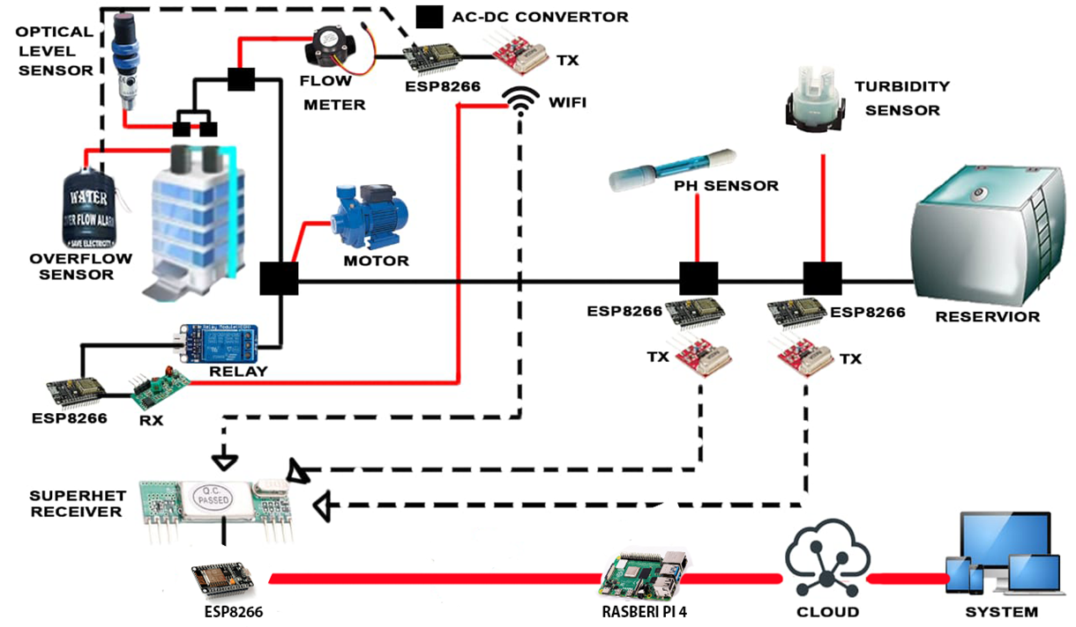

Fig 2.1 Basic Networking for a building

As we can see in above fig is the whole structure for a building. As we can see the whole system work on WiFi. Here we used Tx & Rx for transmitting and receiving the data between every sensor and device.

Every two buildings are connected with 1 Lora Wan through which all the data from the buildings go to the cloud. Which we can excess through our system (like a computer, tablet, and phone) through an internet connection. Since Lora Wan works on the internet so we are using two wide-range routers as shown in the fig.

We have classified our project into 3 categories based on society.

* A grade society
* B grade society
* C grade society ( under government control )

But before moving toward our various society we would like to present our core architecture for 1 building



Fig 2.2 Core Architecture

This is the core structure of our project which gives the idea of how our model is working with various sensors and other devices. As for the communication between every sensor and device we are using Tx & Rx for transmitting and receiving the data so that the whole system becomes wireless and works on wifi. All the real-time data will be received by the Superhet Receiver, sent to the system in the form of the datasheet. Now move toward our sensor and other devices. As we can see water is supplied to all the buildings through an underground water reservoir. Through

a turbidity sensor and pH sensor, we check the contaminant present and pH of the water before delivering it to all the buildings. After that, we used a relay that turns on/off the motor as per the signal received through Rx.

In every building, we used a level sensor, overflow sensor, and water meter. Level sensors provide a signal through Tx when every water level is below the requirement and turn on the motor. It all used to detect leakage in the system.

As for the overflow sensor, it generates an alarm as well as a signal to turn off the motor. And as for the water meter as we get it from its name it is installed in every building to give the data of water consumption of every building and help us to maintain water management and minimize the water leakage in the society.

# Structure development Chapter 3

From the very beginning, our motive is to make a smart water management system with relevant prices for our society which can solve all the problems from basic to high-tech. Since every society have different from with different budget so we decide to divide our project into three categories on the bases of society which we already discussed above i.e.

* A grade society
* B grade society
* C grade society

Reading Tip: Before going on the category let us tell you that we are not categories or discernment in any of the society. All regarding the funds that are required to establish these projects are particular taking into consideration all the three societies. we try our best to provide all the necessary things required to make your society water management smart.

Let’s discuss every society with a diagram. We will move from lower to high-grade society…

1. C grade society: Let’s begin with our first model i.e. for C grade society. Since we all know these types of society run by government bodies or other welfare societies. So there budget is limited and the requirement should be up to mark. So we come up with the most relevant and cost-efficient smart water management system. This the basic model which we have discuss very first of our report. In this model focus on all the basic necessary equipment and smart system with a limited price. As we can see in the given fig all the systems working on a wireless device with a real-time data process at the same time.

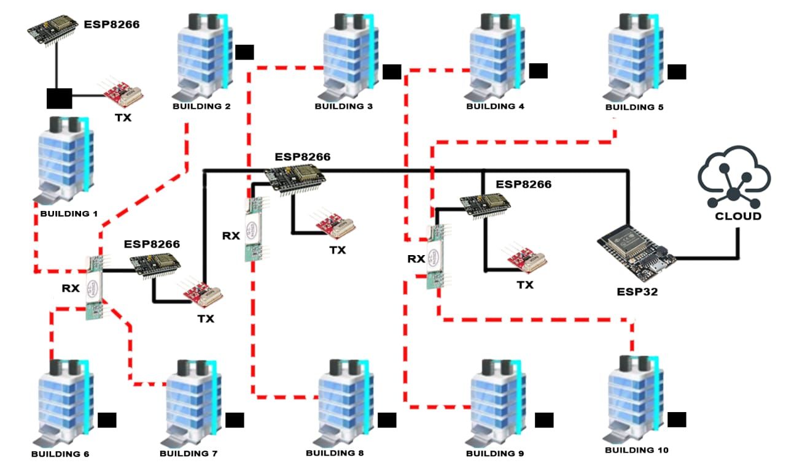

Fig 3.1 block diagram for B grade society

1. B grade society: Now here we present our second model i.e. for B grade society. This model basically focuses on recycling wastewater coming from every building. As we know water wastage is one of the measures problems so we come up with a solution. As we can see there is a tank that collects the wastewater and passes out to remove contaminants present in water by using a water filter and then supply all the clean water to the reservoir.

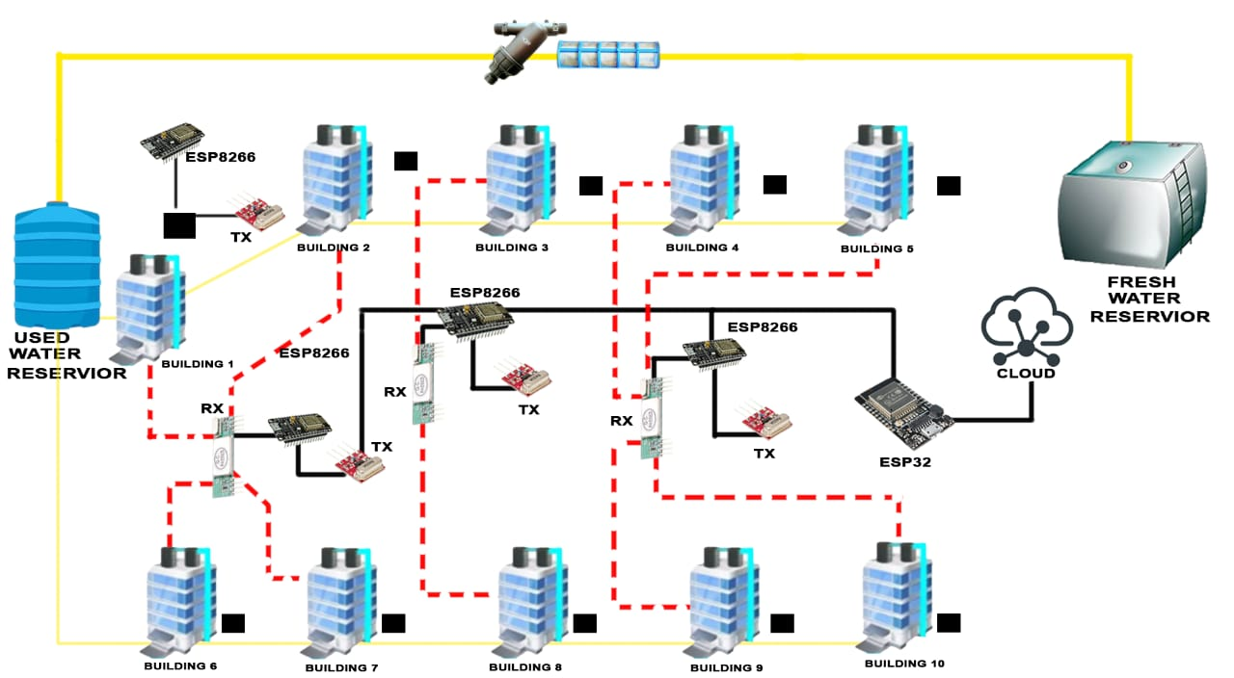

Fig 3.2 block diagram for B grade society

1. A grade society: With our smart budget and a lot of features we present our last but not least model for A grade society. As we know for making a society smart and better we required a smart idea and a whole wireless connected society. As we can see in the below fig there are various tools and smart sensors. Here we used a water filter to recycle and filter wastewater coming from the buildings. Here we used two-tank one or collecting used water after removal of all the contaminants present in water and then Purify which the help of carbon nanotube and move to another tank.

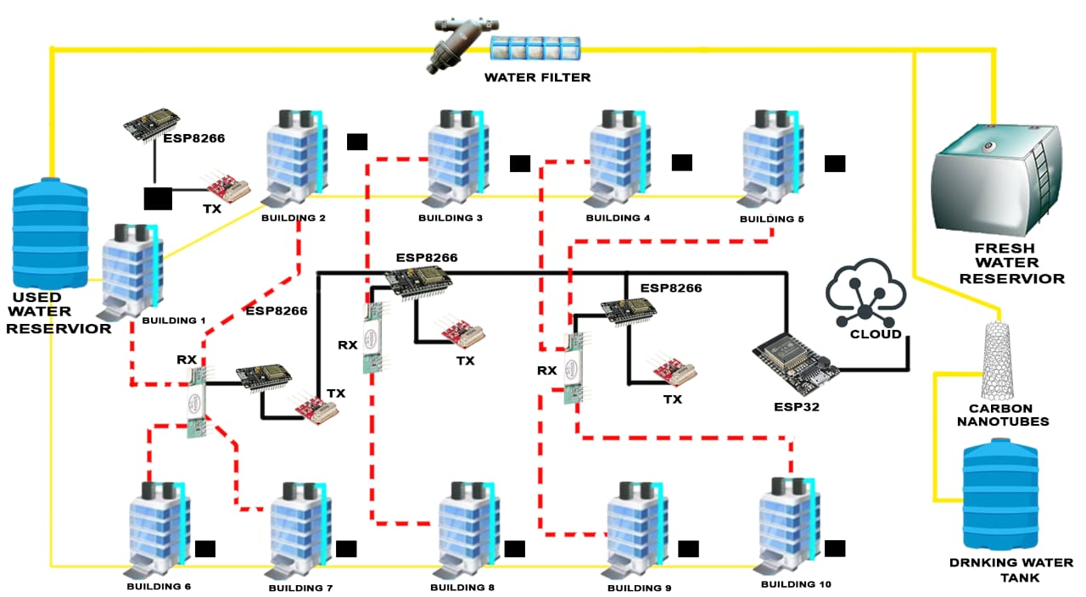

Fig 3.3 block diagram for A grade society

# 

# BUDGET ANALYSING Chapter 4

In our fourth week of this program, our next task is to finalize the budget for all models with their R & D cost value. Our main focus is to make our budget cost-efficient for all the society with the best features.

Here is our budget for all the models with their life span and R&D value.

* **For A grade society :**

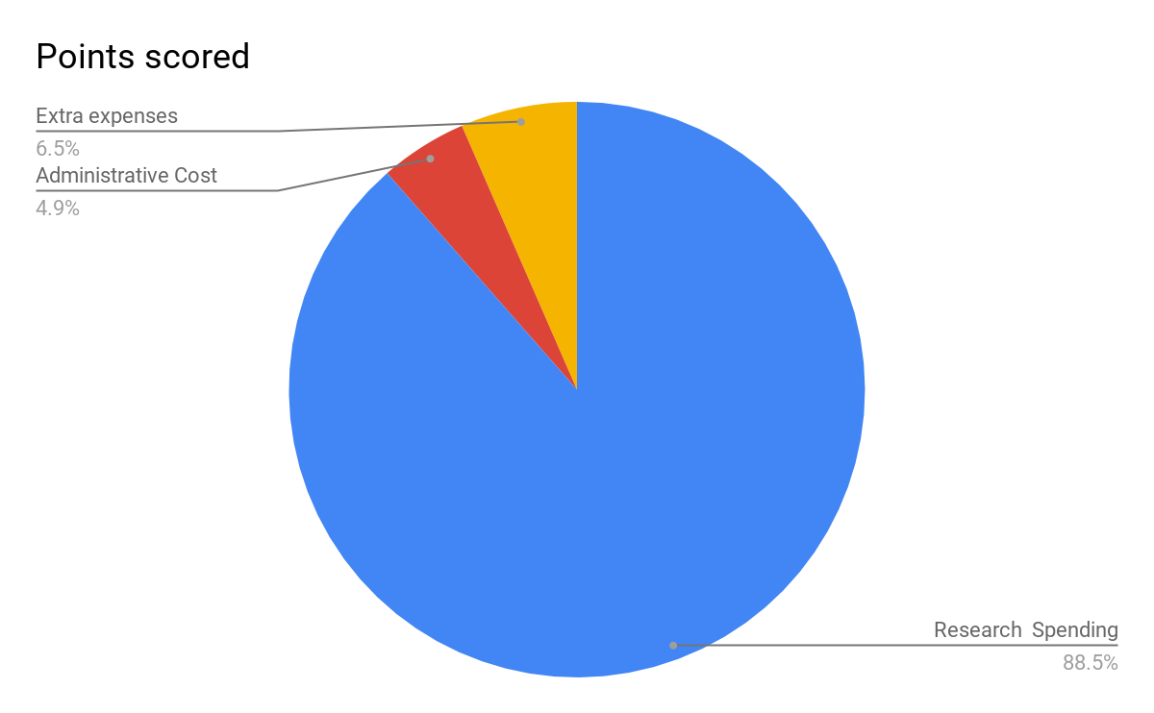

Fig 4.1 Pie chart for A grade society budget

Key points are :

* Cost of A-grade society **₹27,4043.95**
* Other expenses (including administrative cost)  **₹3498**
* Tot amt. **₹30,541.95**
* Commercial Life **more than 10 yrs**

NOTE:- First 6 months free service (charges applicable on part change).

* **For B grade society :**

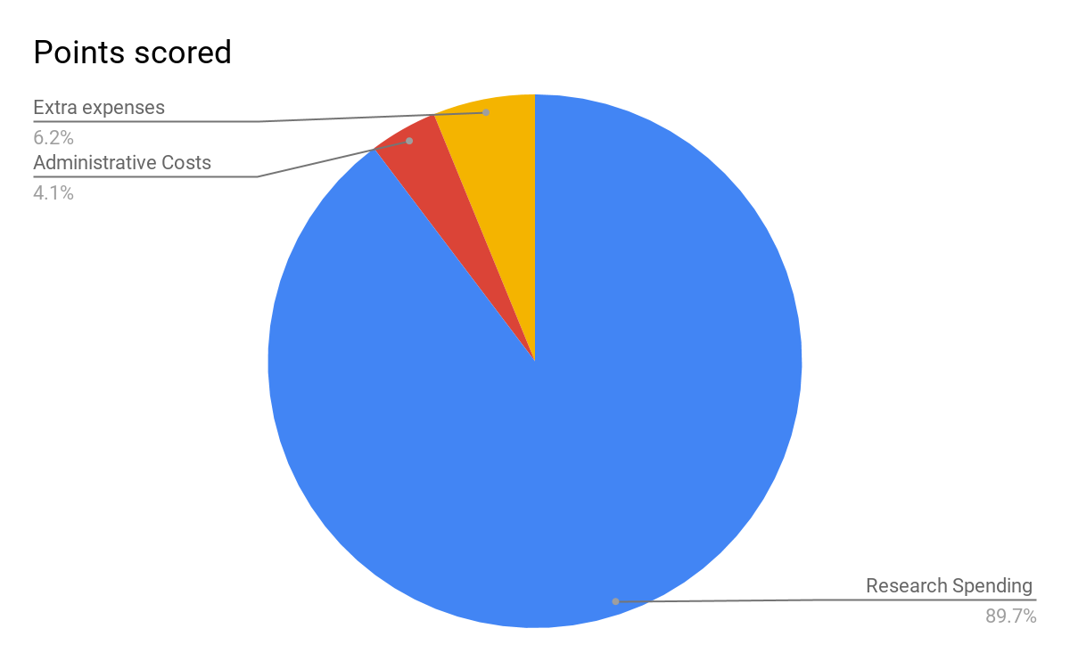

Fig 4.1 Pie chart for B grade society budget

Key points are :

* Cost of B-grade society **₹21752.53**
* Other expenses (including administrative cost)  **₹2499**
* Tot amt. **₹24250.53**
* Commercial Life **10-8 yrs**

NOTE:- First 3 months free service (charges applicable on part change).

* **For C grade society :**

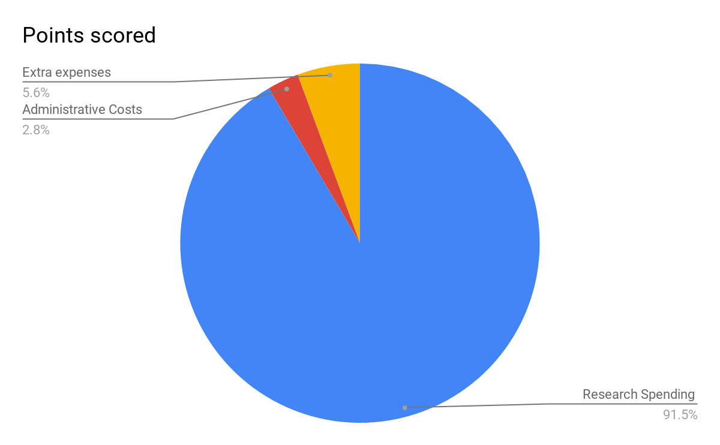

Fig 4.1 Pie chart for C grade society budget

Key points are :

* Cost of C-grade society **₹16206.53**
* Other expenses (including administrative cost)  **₹1498**
* Tot amt. **₹17704.53**
* Commercial Life **up to 6-8 yrs**

` NOTE:- first 1-month free service (charges applicable on part change).

Cloud System

For better communication one of the most important things is better communication which we think the least. So here we take care of our user to provide the best communication between the devices and fast seen to access the data whenever from the system, in a minute, and manage the whole system.

Here we are providing our own Cloud System with the collaboration with Cloudways to keep in track and stay updated about your smart water management system. Cloudways offers around the clock server monitoring so you can have the peace of mind.

Features along with our project are

* Dedicated Environment
* HTTP/2 Supported Servers
* 24/7 Real-time Monitoring
* CloudwaysBot Notifications

BENEFITS AND SILENCE FEATURE OF THIS PROJECT

For any successful project, two things are must that under a smart budget it provide all the best features for both the user and society and not forget it must be eco-friendly.

It is our great hour to finally present our very smart eco-friendly model for the Smart Water Management System.

Before that let’s take a look at all the three models that they offer to the user…

|  |  |  |
| --- | --- | --- |
| For A grade society  Commercial Life:- More than 10 yrs.  Features:-   * Provide all the basic features including in grade B and grade C society. But this is not all it all purify the recycle water coming for drinkable purpose and store it in another tank * .All data related to your tank is on your phone and especially the quality of water provided to you. | For B grade  society  Commercial Life:- up to 8-10 yrs  .  Features:-   * Here we are using a special device i.e. Water filter which filters and removes all the contaminants present in water coming out from the building. * All data related to your tank is on your phone and especially the quality of water provided to you. | For C grade  society  Commercial Life:- up to 6-8 yrs.  Features:-   * This our basic model but full fill all the requirement for society need a smart water management system * all data related to your tank is on your phone and especially the quality of water provided to u. |

* Silence feature of our project :
  + The whole architecture is user friendly and does not require any complex engineering.
  + Totally wireless system.
  + Recycle and remove all the containment present in water coming out of the building.
  + Include a purification system to purify water and recycle it.
  + Fully smart and cost-efficient.

CONCLUSION

It’s important to give your opinion! Would you recommend this book to someone else?

short dash

**Thanking You**

**GROUP - 2 (IInd Year)**

**Members name :**

1. Anubhav Bhardwaj (Leader)
2. Amit Kumar Chaudhary
3. Hrithik Bandil
4. Neeti Jain
5. Pratibha Sharma
6. Rohit Kumar
7. Vibhaw Kumar